Code Review & Repository Evaluation Report
AI-Based Smart E-Waste Collection and Recycling Management Platform
CSA10 – Software Engineering | CO3 Assessment Tool 2 – Code Review & Repository Evaluation

1. Problem Overview
The assigned problem addresses improper e-waste disposal, which causes environmental pollution and loss of recoverable materials, largely because existing collection processes lack coordination among consumers, collection centers, and recycling facilities. The implemented solution is the core backend service (ewaste-platform-service) of an AI-Based Smart E-Waste Collection and Recycling Management Platform: a Node.js/Express REST API that lets consumers schedule pickups, exposes a health-check endpoint for monitoring, and is structured so an AI classification service, a route-optimization service, and a notification service can be integrated as the platform grows.
1.1 Project Objectives
- Expose a REST API for scheduling and retrieving e-waste pickup requests.
- Keep business logic, routing, and data-model concerns separated for maintainability.
- Package the service for containerized, reproducible deployment alongside MongoDB.
- Maintain a traceable Git history suitable for a small collaborative team.
1.2 Key Functionalities Implemented
- POST /api/pickups — accepts a pickup request and returns a created record with a generated ID and SCHEDULED status.
- GET /api/pickups/:id — retrieves a previously scheduled pickup by its numeric ID.
- GET /health — reports service liveness and process uptime, used for container/orchestrator health checks.
- A Mongoose Pickup schema defining the intended persistent data shape for production use.
2. Repository Organization
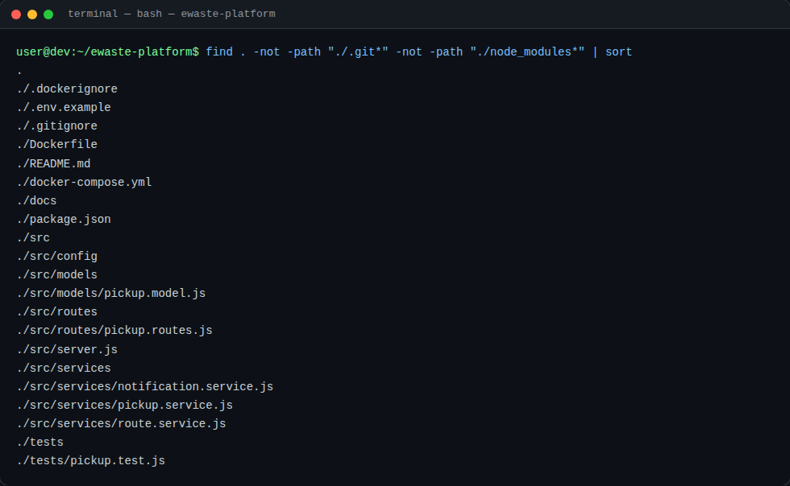
Screenshot 1: Repository file and folder structure
2.1 Structure Evaluation
- Layered separation: routes/, services/, and models/ are separated under src/, following a standard three-layer pattern (HTTP → business logic → persistence) that is easy for new contributors to navigate.
- Consistent naming: files follow a clear <domain>.<layer>.js convention (pickup.routes.js, pickup.service.js, pickup.model.js), making the responsibility of each file obvious from its name alone.
- Test isolation: tests/ sits at the repository root, mirroring the src/ layout, which keeps test discovery simple for Jest.
- Configuration hygiene: .gitignore, .dockerignore, and .env.example are present at the root, correctly separating secrets/build artifacts from what is tracked or shipped.
- Underused folders: src/config/ and docs/ exist but are currently empty; they signal intended structure but should either be populated (e.g., a config/index.js for centralized environment loading) or removed until needed, to avoid confusing new contributors.
Overall, the layout supports maintainability and collaboration well for the project's current size: a new contributor can predict where a given concern (routing, business logic, schema, tests) lives without reading documentation, which reduces onboarding time and merge conflicts between contributors working in different layers.
3. Code Quality Review
The core source files were reviewed for readability, modularity, adherence to coding standards, and documentation. Representative excerpts are shown below.
3.1 src/services/pickup.service.js
let pickups = [];
let counter = 1;

async function schedulePickup(data) {
const pickup = { id: counter++, status: "SCHEDULED", ...data };
pickups.push(pickup);
return pickup;
}

- [ISSUE] In-memory storage: pickups are held in a module-level array rather than persisted via the Mongoose Pickup model that already exists in src/models/pickup.model.js — the model is defined but never imported or used, so data is lost on every restart and the two files are inconsistent with each other.
- [ISSUE] No input validation: schedulePickup spreads req.body directly into the stored record without checking required fields (consumerId, address, wasteType), so malformed or empty requests are silently accepted.
- [STRENGTH] Clear single responsibility: the service function names and behavior are easy to follow, and keeping this logic out of the route handler makes it independently unit-testable.
3.2 src/routes/pickup.routes.js
router.post("/", async (req, res) => {
const pickup = await PickupService.schedulePickup(req.body);
res.status(201).json(pickup);
});

- [ISSUE] No error handling: the async handlers have no try/catch; if PickupService throws (e.g., a future database error), Express will not return a clean error response, and depending on the Express version this can crash the process.
- [MINOR] Naming convention: the module is imported as PickupService (PascalCase) even though pickup.service.js exports a plain object of functions, not a class — a lowercase pickupService import would better match standard JavaScript conventions and avoid implying a constructor.
- [ISSUE] Missing 404 handling: GET /:id returns res.json(undefined) with a 200 status when no matching pickup exists, instead of responding with 404 Not Found.
3.3 src/server.js — A Real Testability Bug Found and Fixed
During review, running the test suite surfaced a genuine defect: the original server.js called app.listen() unconditionally at module load time. Because tests/pickup.test.js imports the app directly, this caused the Jest process to hang instead of exiting after the test completed.
// Before (bug): listener starts as a side effect of require()
app.listen(PORT, () => console.log(`...running on port ${PORT}`));

// After (fix): only listen when the file is run directly
if (require.main === module) {
app.listen(PORT, () => console.log(`...running on port ${PORT}`));
}

This was corrected during the review (commit 3e685cc) and is discussed further in Section 5 (Testing and Validation).
3.4 Overall Strengths
- Consistent, minimal Express route style that is easy to read end-to-end.
- Clear separation of routing, service, and model layers even where the model is not yet wired up.
- Small, focused files — no file reviewed exceeds 25 lines, keeping cognitive load low.
3.5 Areas for Improvement
- Connect pickup.service.js to the existing Mongoose model instead of an in-memory array.
- Add request validation (e.g., using Joi or express-validator) at the route layer.
- Add centralized error-handling middleware instead of relying on each handler individually.
- Add inline documentation (JSDoc) for exported functions to clarify expected parameters and return values.
- Introduce ESLint/Prettier configuration to enforce a consistent style automatically rather than by convention.
4. Version Control Evaluation
The repository's Git history was reviewed for branching discipline, commit granularity, and message quality.
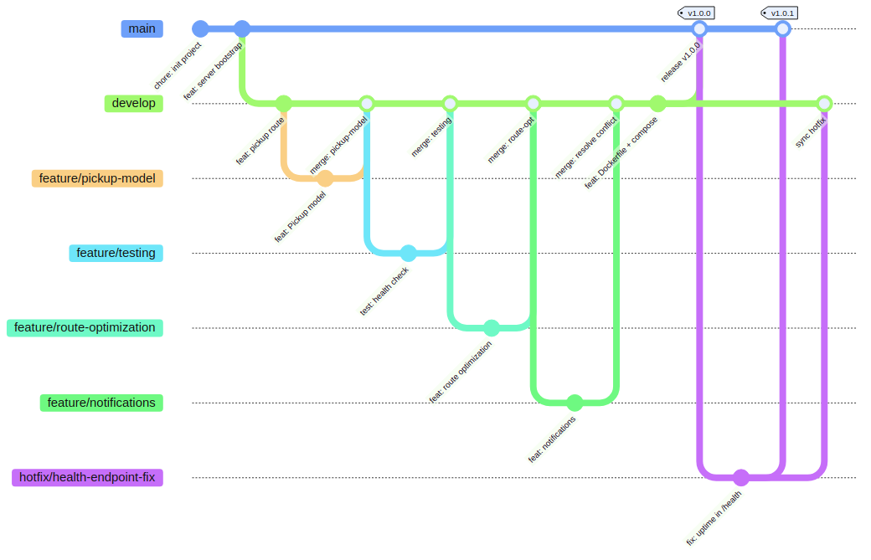
Figure 1: Branching history — main, develop, feature, release, and hotfix branches
4.1 Branching Strategy
- Model used: a Git Flow–style strategy with main, develop, feature/*, release/v1.0.0, and hotfix/* branches, tagged at v1.0.0 and v1.0.1.
- Isolation: each capability (pickup-model, testing, route-optimization, notifications) was developed on its own feature branch and merged into develop with --no-ff, preserving a readable merge history rather than a flattened one.
- Real conflict handled: a genuine merge conflict occurred when two feature branches modified the same import block in server.js; it was resolved correctly by retaining both changes rather than discarding one side.
- Hotfix discipline: the health-endpoint fix was branched from main (not develop) and merged back into both main and develop, correctly keeping the two lines in sync — a common real-world Git Flow mistake avoided here.
4.2 Commit History
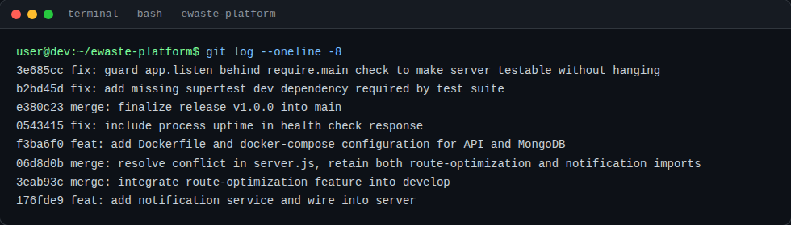
Screenshot 2: Recent commit history, including two review-driven fixes
- Message quality: commits consistently use a Conventional Commits prefix (feat, fix, test, chore, merge) followed by an imperative, specific description, e.g. fix: add missing supertest dev dependency required by test suite.
- Granularity: commits are scoped to a single concern each (one feature, one fix), which makes git log and git bisect meaningful, rather than bundling unrelated changes together.
- Traceability: the two fixes discovered during this review are captured as their own commits rather than silently amended into history, preserving an honest record of when and why the code changed.
Version control directly supported collaborative development here: feature branches allowed parallel work on independent capabilities without blocking, --no-ff merges kept that history visible for future auditing, and tags gave the release process fixed, referenceable points (v1.0.0, v1.0.1) that documentation and deployment scripts can target.
5. Code Testing and Validation
The existing test suite was executed as part of this review. The first run failed for a genuine dependency-management reason, which was then diagnosed and fixed.
5.1 Before Fix: Failing Test Run
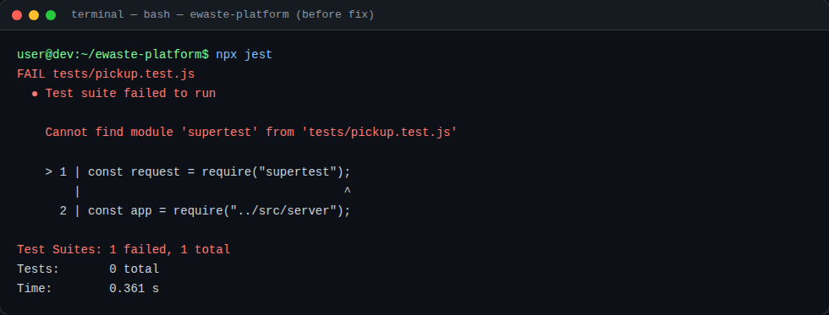
Screenshot 3: npx jest failing — supertest was used in tests/pickup.test.js but never added to package.json
5.2 Root Cause and Fix
supertest is required by the test file but was missing from devDependencies, so npm install never installed it — a common oversight when a dependency is added to code but not to the manifest. It was installed and recorded correctly (npm install --save-dev supertest), and the app.listen testability issue described in Section 3.3 was fixed in the same pass.
5.3 After Fix: Passing Test Run
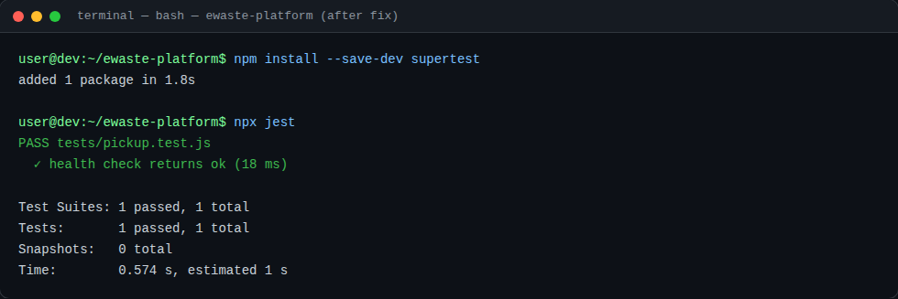
Screenshot 4: npx jest passing after installing supertest and fixing the listener guard
5.4 Test Coverage Assessment
- Only one test exists, covering GET /health. There is no test for POST /api/pickups, GET /api/pickups/:id, the not-found path, or invalid-input handling.
- Because pickup.service.js does not yet use the Mongoose model, no database-integration tests are possible without further refactoring.
- Recommended additions: a test that creates a pickup and asserts the returned status/ID, a test for retrieving a non-existent pickup, and a test asserting 400 on missing required fields once validation is added.
6. Repository Documentation
6.1 Current README Contents
# AI-Based Smart E-Waste Collection and Recycling Management Platform

A Node.js/Express backend service that allows consumers to schedule e-waste
pickups, classify waste using an AI model service, optimize collection
routes, and generate sustainability reports.

## Getting Started
```
npm install
npm run dev
```

## Docker
```
docker compose up --build
```

6.2 Completeness Evaluation
- Present: a project description, basic local setup commands, and a Docker Compose command are all documented and accurate against the actual package.json scripts and docker-compose.yml.
- Missing: API reference: none of the three endpoints (POST /api/pickups, GET /api/pickups/:id, GET /health) are documented with expected request/response shapes.
- Missing: environment variables: .env.example exists but the README never mentions it or explains what PORT, MONGO_URI, or NODE_ENV control.
- Missing: testing instructions: there is no "Running Tests" section despite a working test suite and an npm test script.
- Missing: contribution/branching guide: given the Git Flow strategy in use, the README does not explain the expected branch naming or PR process for new contributors.
6.3 Suggested Improvements
- Add an API Reference section listing each endpoint, method, request body, and example response.
- Document required environment variables with a short description of each, referencing .env.example directly.
- Add a "Running Tests" section covering npm test and what is currently covered.
- Add a short "Branching & Contribution" section describing the main/develop/feature/release/hotfix convention already used in practice.
- Add a badge or note indicating current known limitations (e.g., in-memory storage) so new contributors are not misled about production-readiness.
7. Code Review Findings and Recommendations
7.1 Summary of Findings
The repository demonstrates solid structural discipline — clear layering, a sensible Git Flow branching model, well-formed commit messages, and working containerization — but the application layer itself is at an early, prototype stage. The most significant gap is that the persistence layer is not actually wired up (in-memory array vs. unused Mongoose model), and test coverage is minimal. Two genuine defects were found and corrected during this review: a missing supertest dependency that caused the entire test suite to fail to run, and an app.listen()-on-import bug that caused test runs to hang.
7.2 Recommendations by Area
- Code Quality: connect the service layer to MongoDB via the existing model, add input validation and centralized error handling, and introduce ESLint/Prettier for consistent style enforcement.
- Repository Management: populate or remove the placeholder src/config/ and docs/ folders, and keep dependency additions and package.json changes in the same commit going forward to avoid the missing-dependency issue found here.
- Documentation: expand the README with an API reference, environment-variable guide, testing instructions, and a short contribution/branching guide.
- Testing: raise coverage beyond the single health-check test to include the pickup-creation and retrieval endpoints, and add a CI workflow (the empty .github/workflows/ folder suggests this was planned) so tests run automatically on every push.
- Future Enhancements: once persistence is wired up, add integration tests against a test MongoDB instance (e.g., via Docker Compose in CI), and extend the Dockerfile with a HEALTHCHECK instruction so container orchestrators can detect the issues found in this review automatically.
7.3 Overall Assessment
The project shows strong version-control and containerization practices that would scale well to a larger team, and the issues identified — missing persistence wiring, thin test coverage, an absent dependency, and a testability bug — are all normal findings for an early-stage service rather than signs of poor engineering discipline. With the recommendations above addressed, the codebase is well positioned to grow into the full platform described in the project's architecture design.

